Network Diagram
Student Teacher Interface
Group No.
Group members
Sr. No | Name | Roll No.
1. | Amruta Gurav | 221043
2. | Rahul Jha | 221051
3. | Dakshita Jena | 221050
4. | Asmita Hanchate | 221046

PERT Chart
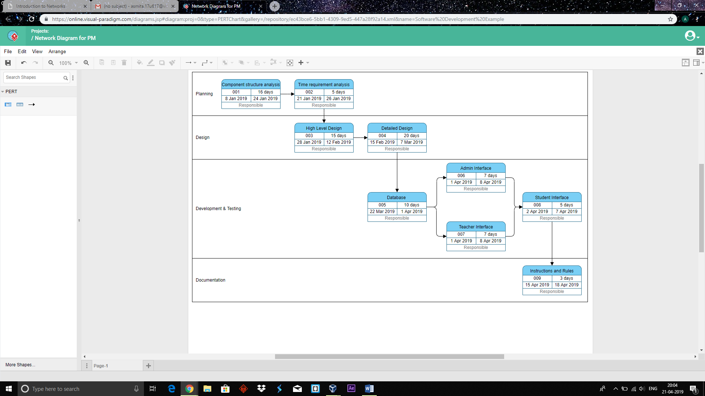
A PERT chart is a project management tool used to schedule, organize, and coordinate tasks within a project. PERT stands for Program Evaluation Review Technique.

